Dataset – 2018 (INDUSTRIEBETRIEB_1) RPN, 28/08/2020

**Summary**

* Anomalies are often visible directly from timelines or via FFT in frequency spectrum
* Quantification possible through classical data analytics
  + *Correlation Factor*
    - weekly rolling correlation (1 vs 2, 2 vs 3, etc.) seems to be more sensitive than correlation against average (1 vs avg, 2 vs avg, etc.)
  + FFT
    - No visible / significant anomalies over whole frequency spectrum
    - Correlation factor calculation of FFT reveals anomalies in frequency spectrum

**Historic Data-based Model**

* Historic data-based model analysis approach:
  + Forms the scientific “expert baseline” for predictive model
  + Goal: design a model that is as good as the historic data-based model analysis
* Historic data-based model analysis description:

WEEKLY STRUCTURED DATA

…

Baseload

Gradient

Zero Detection

Min/Max

YES

Thresold-based Analysis

NÖ

END

Analysis

DAILY Deviation from AVG detected?

Correlation

YES

DAILY STRUCTURED DATA

NÖ

END

Analysis

WEEKLY Deviation from AVG detected?

Correlation

FFT

* Historic data-based model analysis sample:
  + 1) Structure weekly data

|  |  |  |  |  |
| --- | --- | --- | --- | --- |
| UTC_TIME | KWH_WEEK_1 | KWH_WEEK_2 | … | KHW_AVG |
| 20200820T08:00+00:00 | 5.000 | 2.000 | … | 3.500 |
| … | … | … | … | … |

* + 2) FFT analysis per week

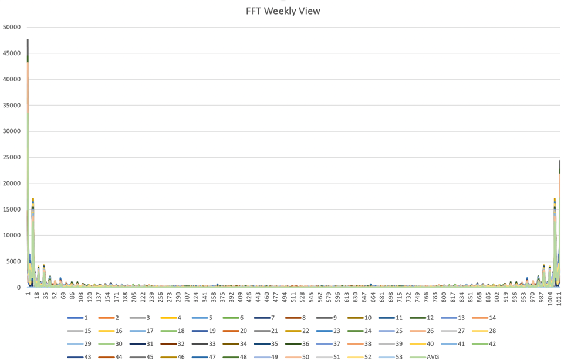

* + 3) Calculation of correlation factor of weekly data (against previous week & against overall avg.)

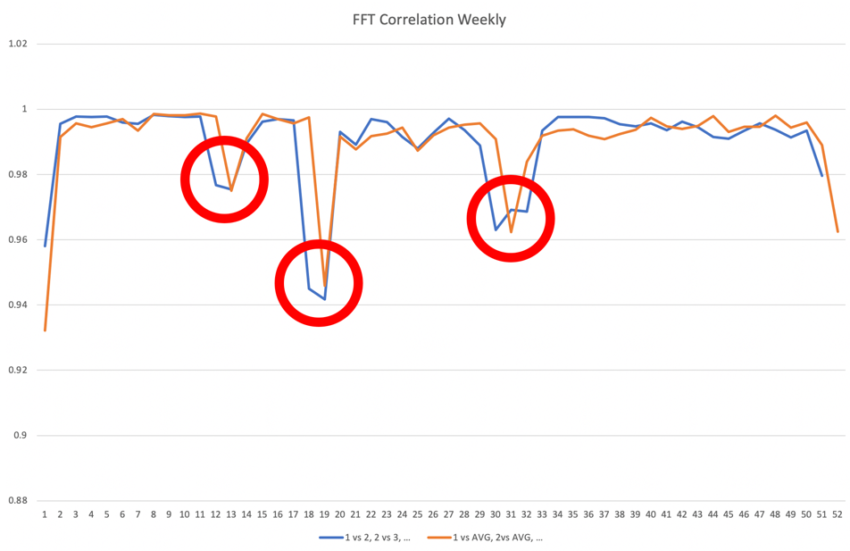

* + 4) Detection of “out of ordinary” correlation (especially “good” / especially “bad”) 🡪 kind of a thresholding on correlation curve 🡪 identification of irregular weeks 🡪 focus on week 18/19
  + 5) Structure daily data

|  |  |  |  |  |  |
| --- | --- | --- | --- | --- | --- |
| UTC_TIMESTAMP | WEEKDAY | WEEK_1 | WEEK_2 | … | AVG |
| 08:00+00:00 | MO | 5.000 | 2.000 | … | 3.500 |
| … | … | … | … | … | … |

* + 6) Calculate correlation factor of daily data (against previous weeks & against overall avg.)
  + 7) Drill down on daily correlation factor and identifiy “suspicious” days

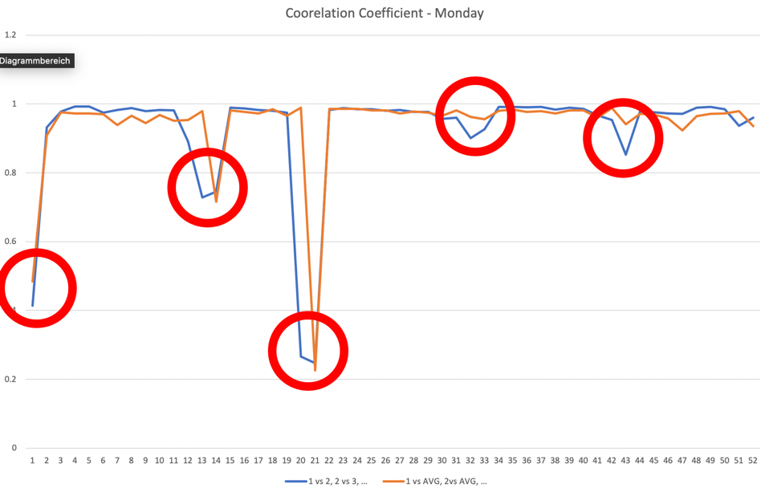

🡪 IRREGULARITY for MONDAY week 19 DETECTED

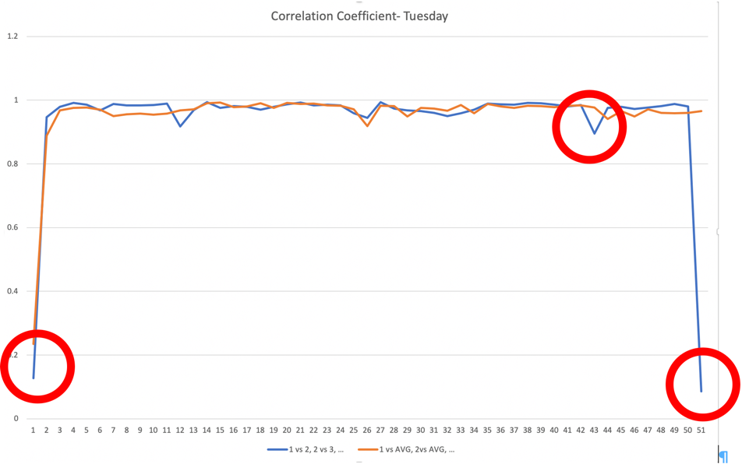

🡪 NO IRREGULARITY for TUESDAY week 19 detected

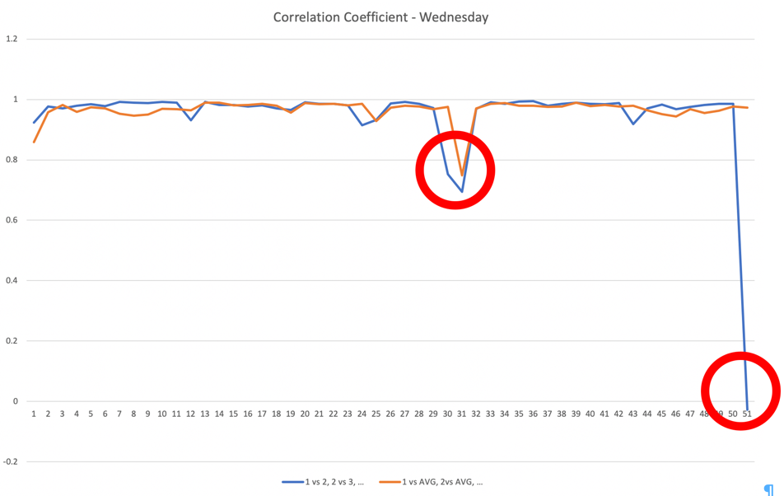

🡪 NO IRREGULARITY for WEDNESDAY week 19 detected

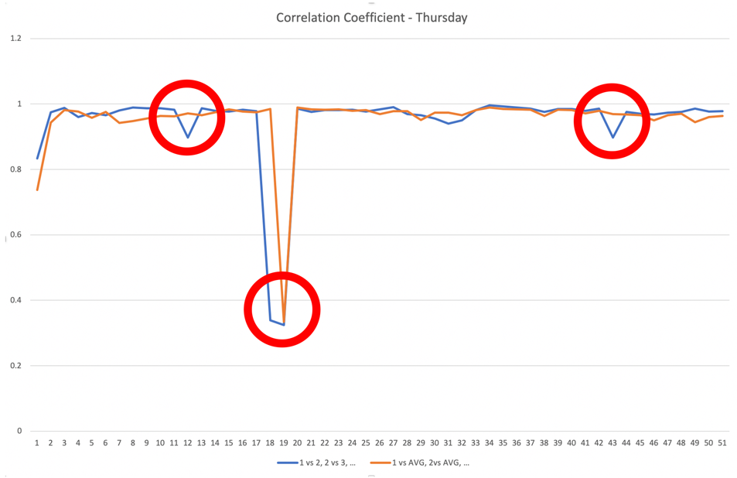

🡪 IRREGULARITY for THURSDAY week 19 DETECTED

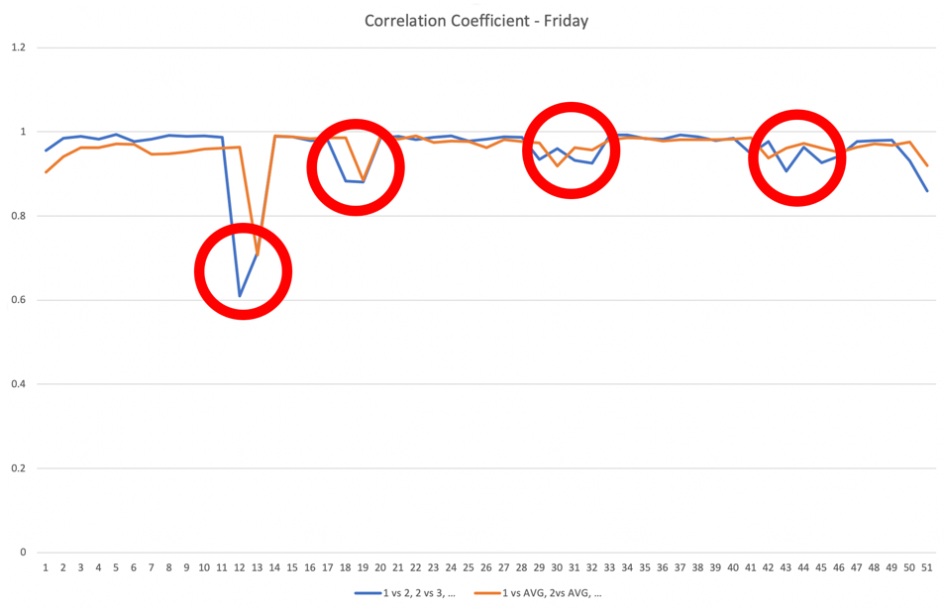

🡪 IRREGULARITY for FRIDAY week 19 DETECTED

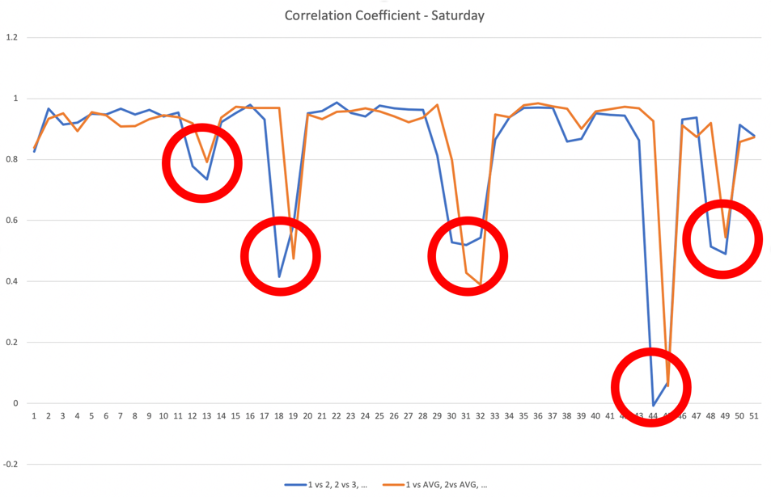

🡪 IRREGULARITY for SATURDAY week 19 DETECTED

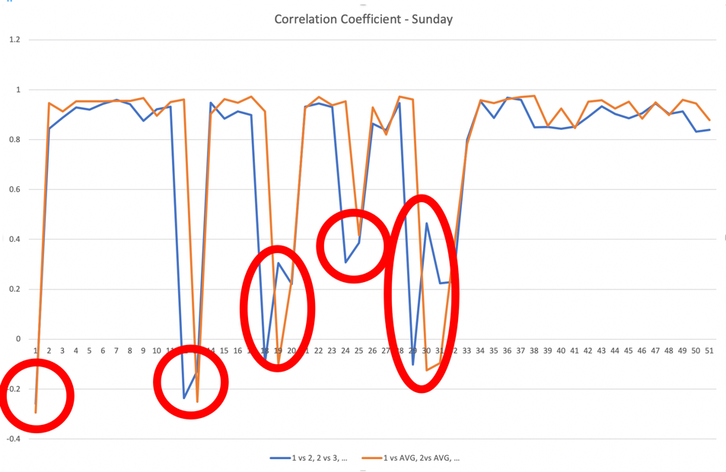

🡪 IRREGULARITY for SUNDAY week 19 DETECTED

**🡪 IRREGULARITIES on MONDAY, THURSDAY, FRIDAY, SATURDAY and SUNDAY in week 19 DETECTED!**

* + 8) Identify anomalies in time series display

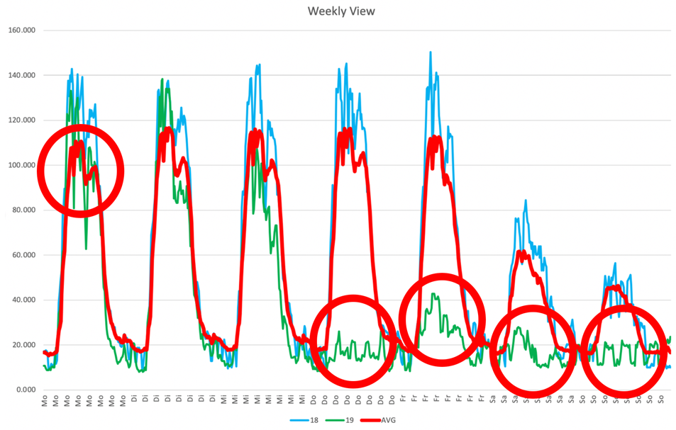

* *Monday*: week 19 Monday load curve has higher ripple than avg. Monday load curve of the year 🡪 IRREGULARITY!
* *Tuesday*: high correlation of week 19 Tuesday load curve vs. avg. Tuesday load curve 🡪 no irregularity!
* *Wednesday*: high correlation of week 19 Wednesday load curve vs. avg. Wednesday load curve 🡪 no irregularity!
* *Thursday*: week 19 Thursday load curve has lower amplitude than avg. Thursday load curve of the year 🡪 IRREGULARITY!
* *Friday*: week 19 Friday load curve has lower amplitude than avg. Friday load curve of the year, although signal form correlation is higher than for Thursday 🡪 IRREGULARITY!
* *Saturday*: week 19 Saturday load curve has lower amplitude than avg. Saturday load curve of the year 🡪 IRREGULARITY!
* *Sunday*: week 19 Sunday load curve has lower amplitude than avg. Sunday load curve of the year 🡪 IRREGULARITY!

APPENDIX

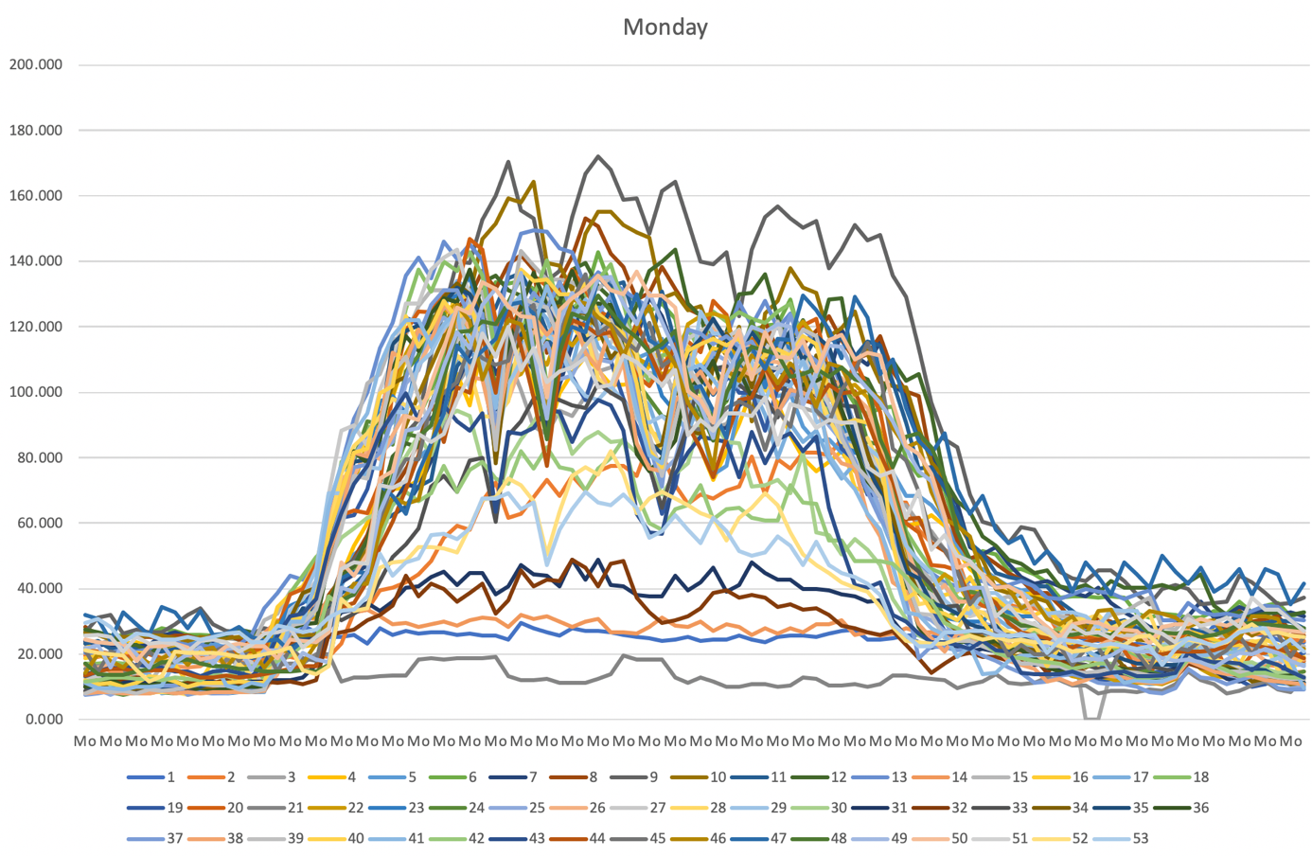

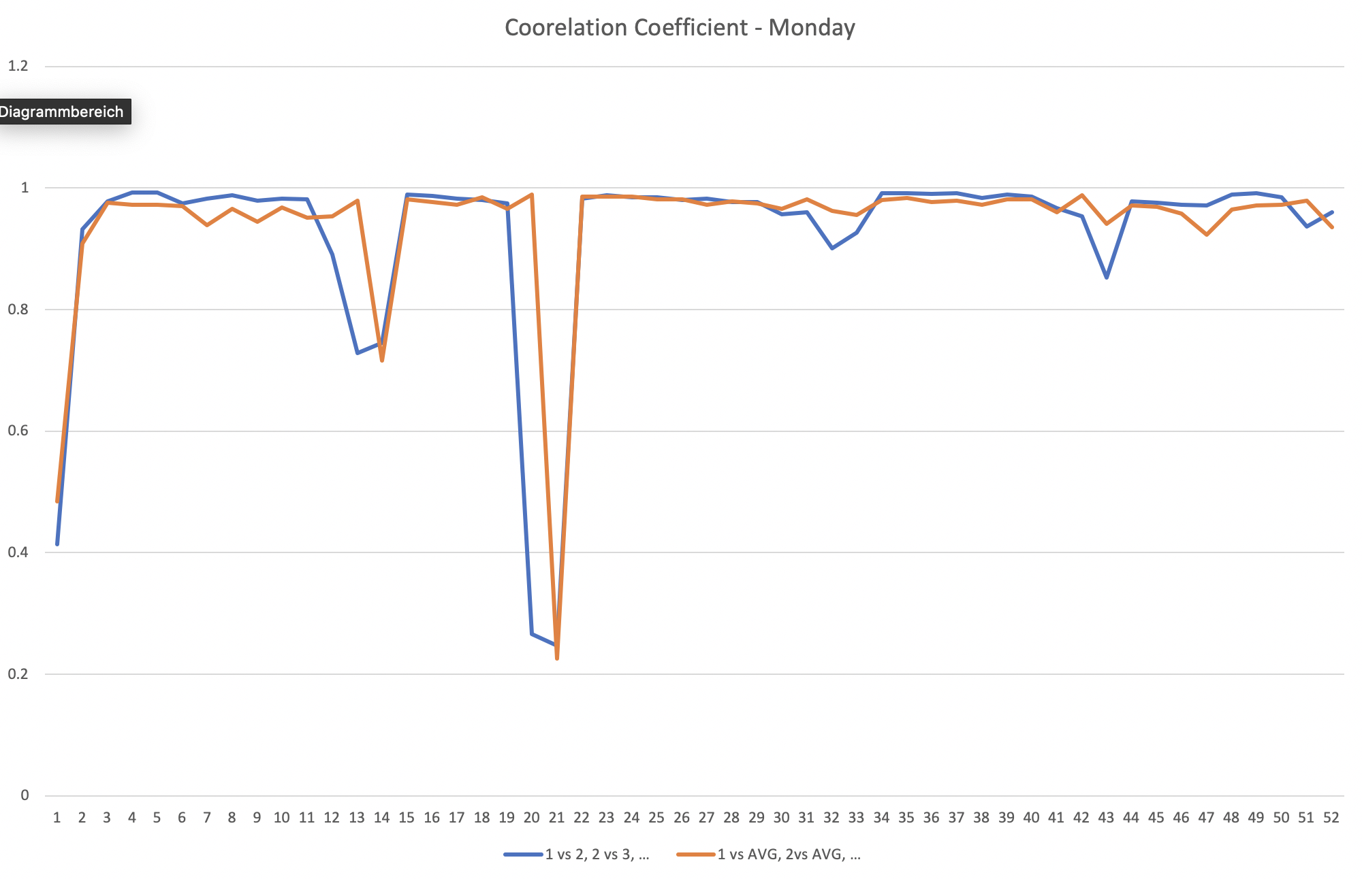

1 vs 2, 2 vs 3, etc. = Correlation of current weekday with previous week

1 vs AVG, 2 vs AVG, etc. = Correlation of current weekday with overall average

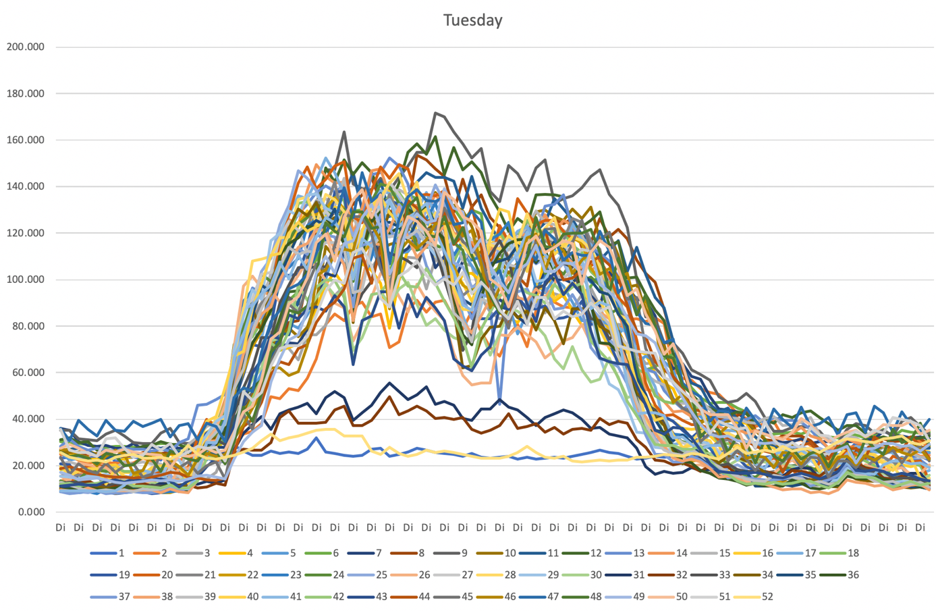

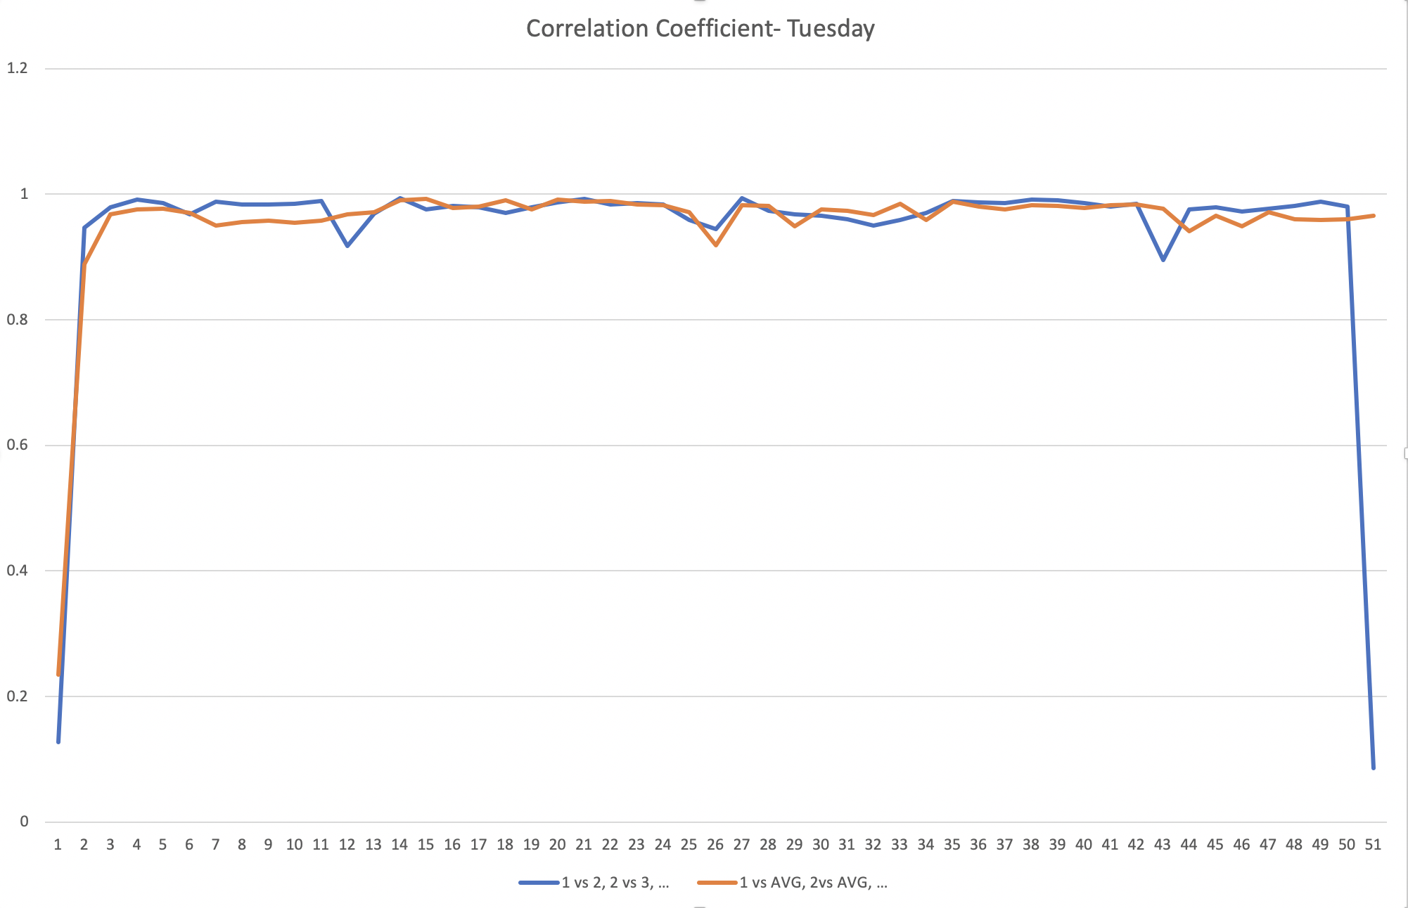

1 vs 2, 2 vs 3, etc. = Correlation of current weekday with previous week

1 vs AVG, 2 vs AVG, etc. = Correlation of current weekday with overall average

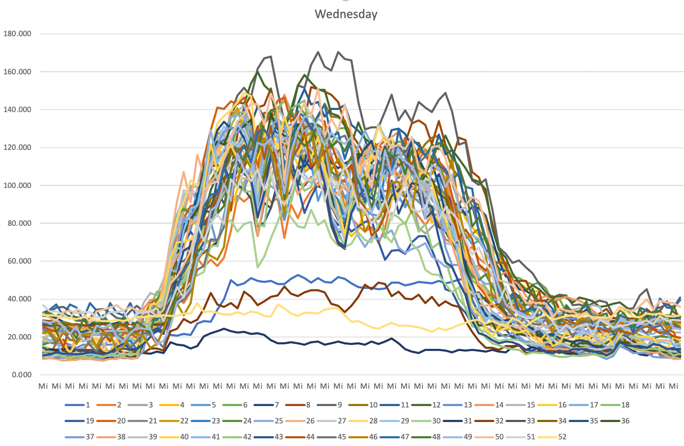

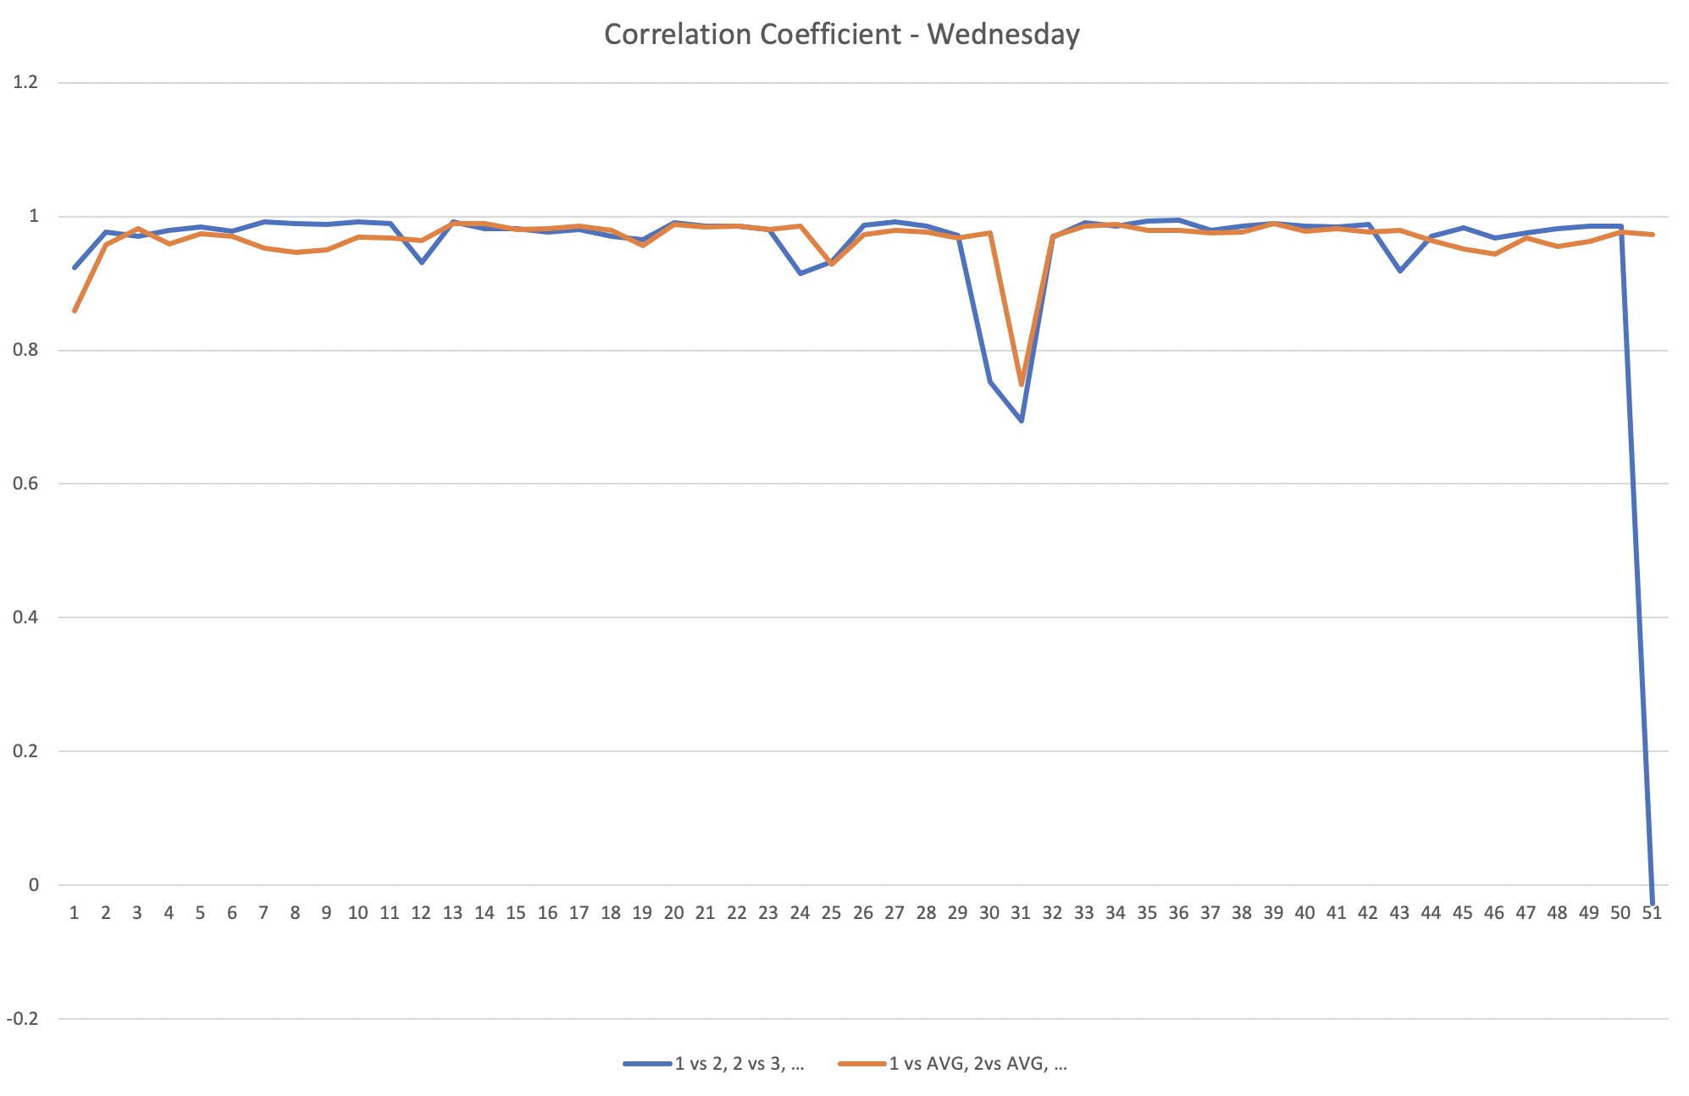

1 vs 2, 2 vs 3, etc. = Correlation of current weekday with previous week

1 vs AVG, 2 vs AVG, etc. = Correlation of current weekday with overall average

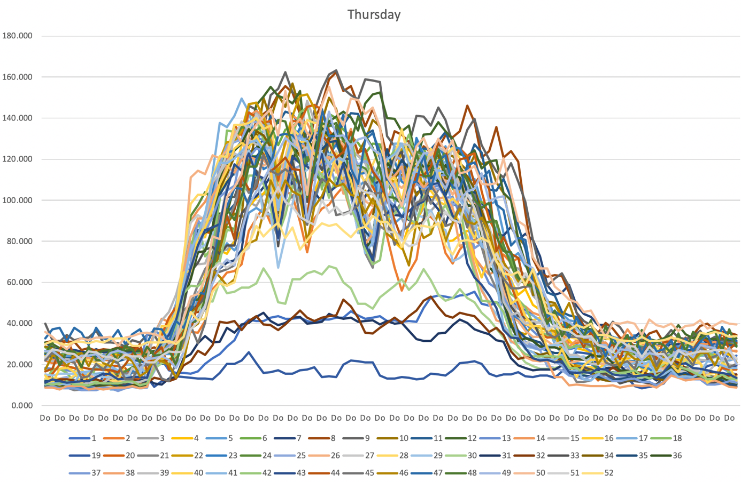

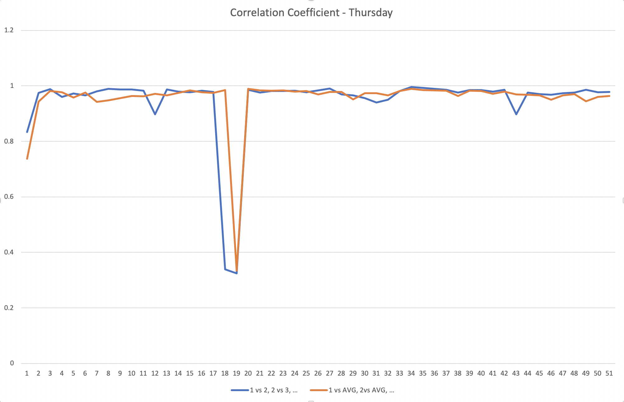

1 vs 2, 2 vs 3, etc. = Correlation of current weekday with previous week

1 vs AVG, 2 vs AVG, etc. = Correlation of current weekday with overall average

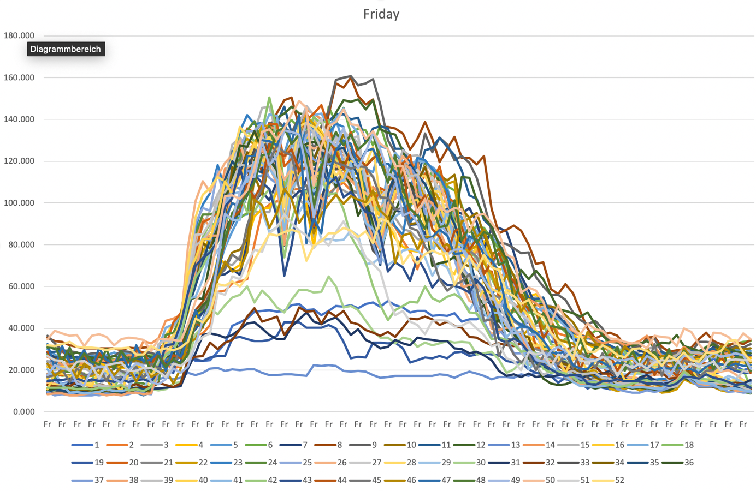

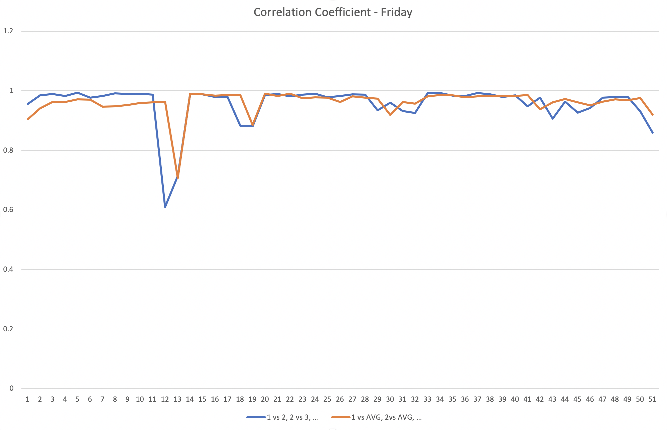

1 vs 2, 2 vs 3, etc. = Correlation of current weekday with previous week

1 vs AVG, 2 vs AVG, etc. = Correlation of current weekday with overall average

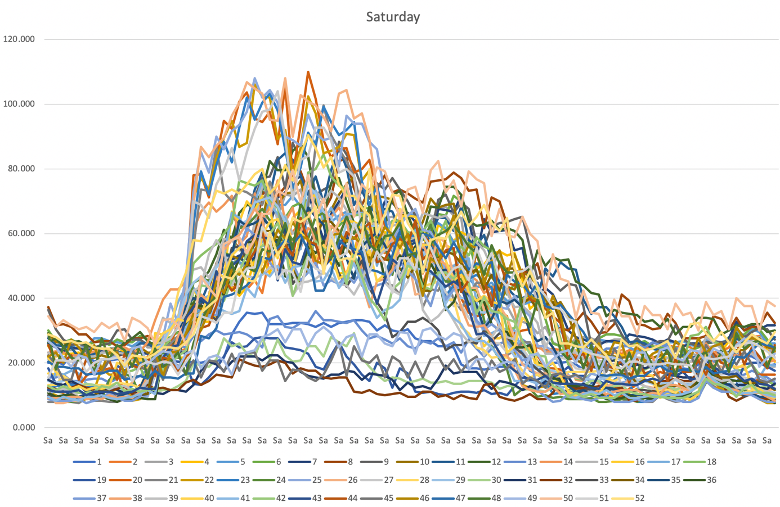

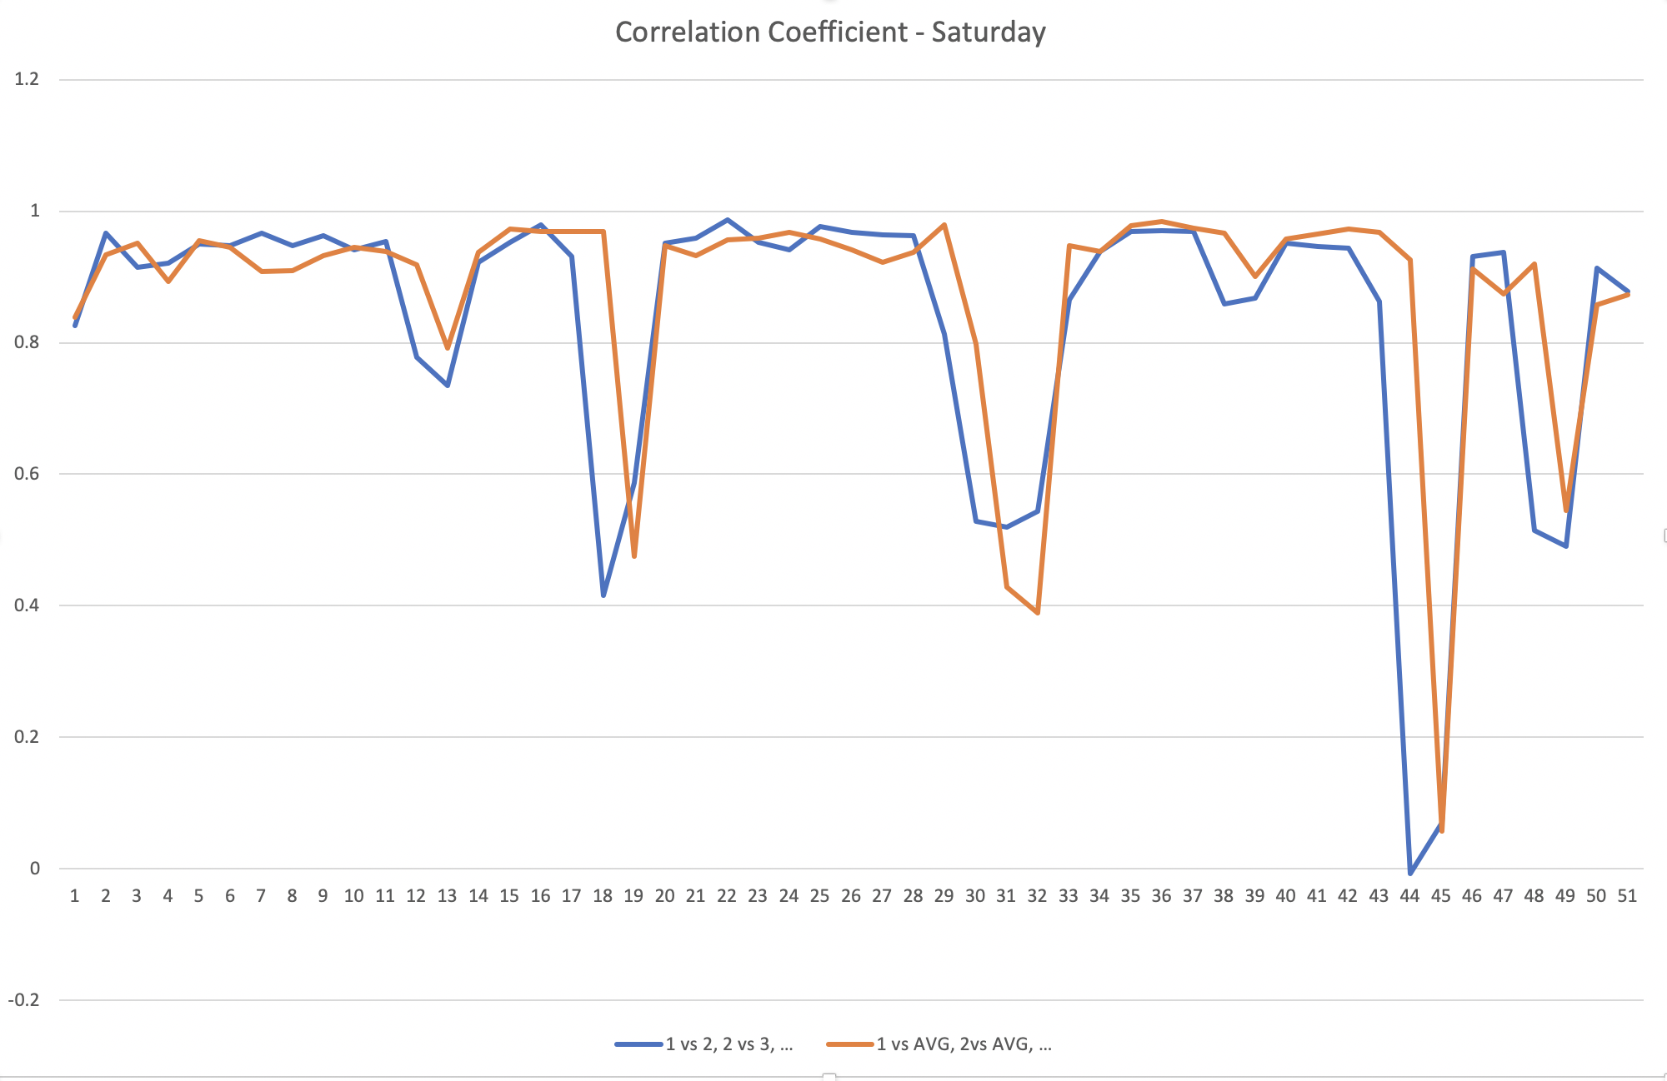

1 vs 2, 2 vs 3, etc. = Correlation of current weekday with previous week

1 vs AVG, 2 vs AVG, etc. = Correlation of current weekday with overall average

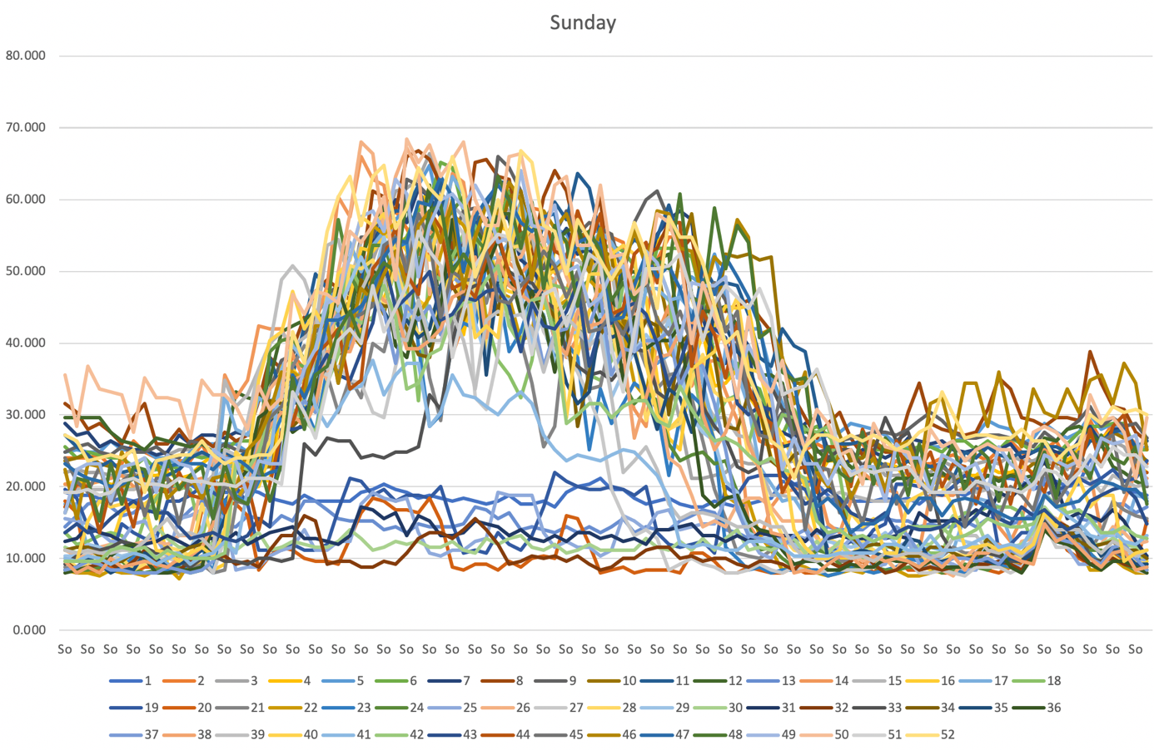

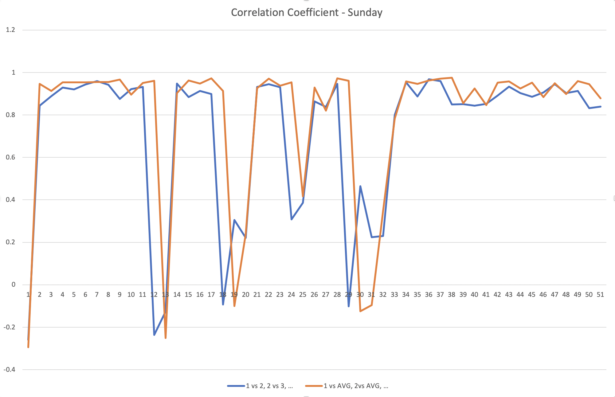

1 vs 2, 2 vs 3, etc. = Correlation of current weekday with previous week

1 vs AVG, 2 vs AVG, etc. = Correlation of current weekday with overall average

